**Institute of Space Technology**

**Programming fundamentals LAB PROJECT**

**Submitted By: Abdullah Ahmad**

**Reg#200901057**

**Section: BSCS 01-B**

**Submitted To: Sir Asad Khan**

**Introduction:**

Our billing system is based on the concept to generate the bill reports and to add items and update their details. The whole concept is designed via c++ language.

This billing system is a simple console application built in C++ without the use of graphics. This project will help you understand basically two things – use of stream class and file handling in c++ programming language.

**Code:**

#include <iostream> #include <cstdlib> #include <ctime> #include <string> using namespace std;

double game;

//1. hangman Game start// int hangman ()

{

int letterFill (char, string, string&);

int tries=3; char letter;

int wrong_guesses=0; string word;

string words[] =

{"punjab", "balochistan", "sindh", "KPK", "NWFP"};

//select random word from array and replace all of it's characters with * srand(time(NULL));

int n=rand()% 5; word=words[n];

string unknown(word.length(),'*');

//game body that will show in output cout <<endl;

cout << "Hangman Game";

cout << "\n\nYou have " << tries << " tries to try and guess the word."<<endl;

// Loop until the guesses are used up while (wrong_guesses < tries)

{

cout << unknown;

cout << "\n\nGuess a letter: "; cin >> letter;

// Fill secret word with letter if the guess is correct, otherwise increment the number of wrong guesses.

if (letterFill(letter, word, unknown)==0)

{

cout << endl << "wrong guess" << endl; wrong_guesses++;

}

else

{

cout << endl << "letter found. Find other letters." << endl;

}

// Tell user how many guesses has left.

cout << "You have " << tries - wrong_guesses; cout << " guesses left." << endl;

// Check if user guessed the word. if (word==unknown)

{

cout << word << endl;

cout << "Congrats! You won the Game"; break;

}

}

if(wrong_guesses == tries)

{

cout << "\nSorry, you lose...you've been hanged." << endl; cout << "The word was : " << word << endl;

}

}

/* Take a one character guess and the secret word, and fill in the unfinished guessword. Returns number of characters matched.

Also, returns zero if the character is already guessed. */

int letterFill (char guess, string secretword, string &guessword)

{

int i;

int matches=0;

int len=secretword.length(); for (i = 0; i< len; i++)

{

// Did we already match this letter in a previous guess? if (guess == guessword[i])

return 0;

// Is the guess in the secret word? if (guess == secretword[i])

{

guessword[i] = guess; matches++;

}

}

return matches;

}

//hangman Game end//

//price is right start

float a;

void priceisright()

{ int guessprice,num;

cout<<"press 1 to guess price of Food items"<<endl; cout<<"press 2 to guess price of Furniture items"<<endl; cout<<"press 3 to guess price of Transport items"<<endl; cout<<"press 4 to guess price of lifstyle items"<<endl; cout<<"Press 5 to guess price of Electronics items"<<endl; cout<<"press 6 to guess price of Antiques items"<<endl; cin>>num;

if(num==1)

{ cout<<" press 1 to guess price of Oatmeal"<<endl; cout<<" press 2 to guess price of Coffy Beans"<<endl; cout<<" press 3 to guess price of Tea Leaves"<<endl; cin>>guessprice;

switch(guessprice)

{ case 1:

cout<<"enter price"<<endl; cin>>a;

if (a>=20.96 && a<=30.96)

{ cout<<"You are winner "<<endl;

}

else

{ cout<<"sorry you lost"<<endl;

}

break; case 2:

cout<<"enter price"<<endl; cin>>a;

if (a>=33 && a<=43)

{ cout<<"you are winner"<<endl;

}

else

{ cout<<"sorry you lost"<<endl;

}

break; case 3:

cout<<"enter price"<<endl;

cin>>a;

if (a>=40 && a<=50)

{ cout<<"you are winner"<<endl;

}

}

else if(num==2)

}

else

{ cout<<"sorry you lost"<<endl;

}

break; default:

cout<<"wrong entry try again";

{ cout<<" press 1 to guess price of Sofa"<<endl; cin>>guessprice;

switch(guessprice)

{ case 1:

cout<<"enter price"<<endl; cin>>a;

if (a>=144.2 && a<=159.6)

{ cout<<"you are winner"<<endl;

}

else

{ cout<<"sorry you lost"<<endl;

}

break; default:

cout<<"wrong entry try again";

}

}

else if(num==3)

{ cout<<" press 1 to guess price of Car "<<endl; cin>>guessprice;

switch(guessprice)

{ case 1:

cout<<"enter price"<<endl; cin>>a;

if (a>=5915.582 && a<=6055.582)

{ cout<<"you are winner"<<endl;

}

else

{ cout<<"sorry you lost"<<endl;

}

}

else if (num==4)

}

break; default:

cout<<"wrong entry try again";

{ cout<<" press 1 to guess price of Watch"<<endl; cin>>guessprice;

switch(guessprice)

{ case 1:

cout<<"enter price"<<endl; cin>>a;

if (a>=162.242 && a<=510.50)

{ cout<<"Conrats you are winner"<<endl;

}

else

{ cout<<"bad luck mate you lost"<<endl;

}

break; default:

cout<<"wrong entry try again";

}

}

else if(num==5)

{ cout<<" press 1 to guess price of Smart Tv"<<endl; cout<<" press 2 to guess price of Laptop"<<endl; cin>>guessprice;

switch(guessprice)

{ case 1:

cout<<"enter price"<<endl; cin>>a;

if(a>=3673.039 && a<=4680.848)

{ cout<<"congratulations you are winner"<<endl;

}

else

{ cout<<"sorry you lost "<<endl;

}

break;

case 2:

cout<<"enter price"<<endl;

cin>>a;

if (a>=4374.65 && a<=5382.459)

{ cout<<"congrats you won "<<endl;

}

else

}

}

{ cout<<"sorry you lost "<<endl;

}

break; default:

cout<<"wrong entry try again";

else if (num==6)

{ cout<<" press 1 to guess price of Grandfather Clock"<<endl; cin>>guessprice;

switch(guessprice)

{ case 1:

cout<<"enter price"<<endl; cin>>a;

if (a>=2536.742 && a<=8500.689)

{ cout<<"you are winner"<<endl;

}

else

{ cout<<"You lost"<<endl;

}

break; default:

cout<<"wrong entry try again";

}

} else

{ cout<<"enter correct number "<<endl;

}

}

//price is right ends

//quiz show starts

int i;

string answer;

void English() {

cout<<"What is a comma used after the penultimate item in a list of three or more items, (before \'and\' or \'or\') is called?"<<endl;

cin >> ws; getline(cin, answer);

if(answer == "Oxford comma"){ cout<<"You are the Winner"<<endl;

cout<<"Remaining turns ";

cout<<(i*-1)+2<<endl<<endl;

}

else{

}

}

cout<<"You lose"<<endl; cout<<"Remaining turns ";

cout<<(i*-1)+2<<endl<<endl;

void Sports(){

cout<<"Where will the 2024 Olympics take place?"<<endl; cin >> ws;

getline(cin, answer); if(answer == "Paris"){

cout<<"You are the Winner"<<endl;

}

else{

}

}

cout<<"Remaining turns ";

cout<<(i*-1)+2<<endl<<endl;

cout<<"You lose"<<endl; cout<<"Remaining turns ";

cout<<(i*-1)+2<<endl<<endl;

void Maths(){

cout<<"Which theorem represents the fundamental relation in Euclidean geometry among the three sides of a right triangle?"<<endl;

cin >> ws; getline(cin, answer);

if(answer == "Pythagorean-theorem"){ cout<<"You are the Winner"<<endl;

}

else{

}

}

cout<<"Remaining turns ";

cout<<(i*-1)+2<<endl<<endl;

cout<<"You lose"<<endl; cout<<"Remaining turns ";

cout<<(i*-1)+2<<endl<<endl;

void Science(){

cout<<"What is the scientific name given to humans?"<<endl; cin >> ws;

getline(cin, answer);

if(answer == "Homo-sapiens"){ cout<<"You are the Winner"<<endl;

cout<<"Remaining turns ";

cout<<(i*-1)+2<<endl<<endl;

}

else{

cout<<"You lose"<<endl; cout<<"Remaining turns ";

cout<<(i*-1)+2<<endl<<endl;

}

}

void History(){

cout<<"When did Pakistan came into being? "<<endl; cin >> ws;

getline(cin, answer);

if(answer == "14-August-1947"){ cout<<"You are the Winner"<<endl;

}

else{

}

}

cout<<"Remaining turns ";

cout<<(i*-1)+2<<endl<<endl;

cout<<"You lose"<<endl; cout<<"Remaining turns ";

cout<<(i*-1)+2<<endl<<endl;

void quizgame(){

for(i=0 ; i<3 ; i++){

char category;

cout<<"--------This is the Quiz Game "<<endl;

cout<<"Choose From the given category"<<endl; cout<<"\t A. English"<<endl;

cout<<"\t B. Sports"<<endl; cout<<"\t C. Mathematics"<<endl; cout<<"\t D. Science"<<endl; cout<<"\t E. History"<<endl; cout<<"Choose one option: ";

cin>>category;

if( category=='a'||category=='A'){ English();

}

else if( category=='b'||category=='B'){ Sports();

}

else if( category=='c'||category=='C'){ Maths();

}

else if( category=='d'||category=='D'){ Science();

}

else if( category=='e'||category=='E'){ History();

}

}

}

//quiz show ends

//spin the wheel starts

int spinthewheel()

{

srand((unsigned)time(0)); int number;

number = (rand()%9);

cout <<"your lucky number is:" <<number << "\n";

switch (number) { case 1:

cout <<"Congratulations you won Watch. \n"; break;

case 2:

cout <<"Congratulations you won Mobile phone. \n"; break;

case 3:

cout <<"Congratulations you won Electric kettle. \n"; break;

case 4:

cout <<"Congratulations you won Heater \n"; break;

case 5:

cout <<"Congratulations you won Iron. \n"; break;

case 6:

cout <<"Congratulations you won Backpack. \n"; break;

case 7:

cout <<"Congratulations you won Suitcase set. \n"; break;

case 8:

cout <<"Congratulations you won Camera. \n"; break;

case 0:

cout <<"Congratulations you won Travel mug \n"; break;

}

//spin the wheel ends

}

int mainmenu()

{

cout <<"\n\nPress 1 to Play Hangman Game \nPress 2 to play price is right Game \nPress 3 to play quizshow Game \nPress 4 to play Spin the wheel \nPress 5 to quit the programe" <<endl;

cin >> game; return game;

}

int main()

{

string leader;

cout <<"\nWelcome to Group 2's Game console ";

cout <<"\n \nPlease Provide Group's leader name" <<endl; cin>>leader;

cout <<"\n \nLeader's Name is "<<leader<<endl; int length = leader.length();

cout <<"\n\nThe Group leader has " << length <<" characters in his name therefore you get to play each game " << length-2 << " instead of spin the wheel Game\nwhose ascii value of first letter is equal to ascii value of first letter of leaders Name" <<endl;

length = length-2;

cout <<"\n\nLet's Go and Start the Games" <<endl;

int count=0, hangmancount=0,priceisrightcount=0 , quizgamecount=0; while (game!=5)

{

mainmenu();

if (game>=1 && game<=4)

{

if (game==1)

{

if (hangmancount<length)

{

hangman(); hangmancount++;

}

else

cout<<"You have already played this game max times"<<endl;

}

else if(game==2)

{

if (priceisrightcount<length)

{

priceisright (); priceisrightcount++;

}

else

cout<<"You have already played this game max times"<<endl;

}

else if(game==3)

{

if (quizgamecount<length)

{

quizgame(); quizgamecount++;

}

else

cout<<"You have already played this game max times"<<endl;

}

else if(game==4)

spinthewheel();

}

}

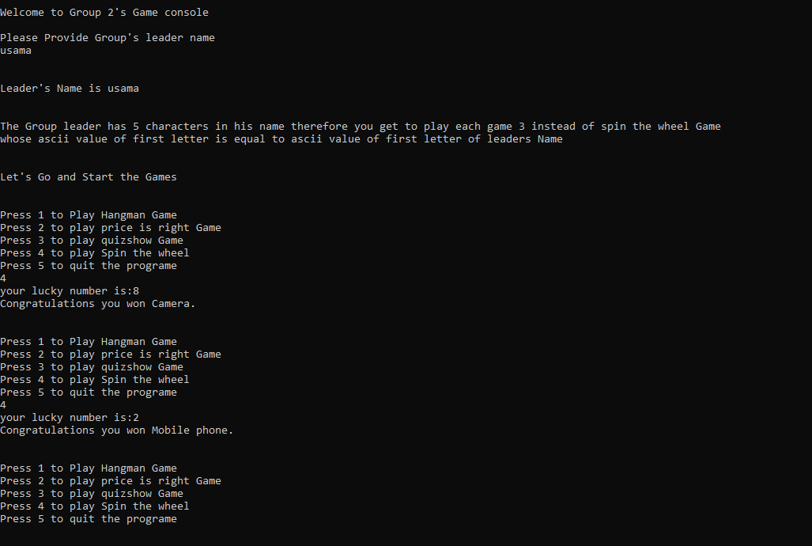cout <<"Program ended . Thank you for playing";}

**Output:**

